 | Assignment No. 03  Semester: Fall 2020  CS304- Object Oriented Programming |  | Total Marks: 20  Due Date: 27/01/2021
Objective
The objective of this assignment is:
To give you the idea of practical implementation of C++ Inheritance and Polymorphism.

Uploading instructions:

- Your assignment should be in .CPP format (Any other formats like scan images, PDF, zip, doc, rar and bmp etc. will not be accepted).
- Save your assignment with your ID (e.g. bc000000000.CPP).
- No assignment will be accepted through email.

Rules for Marking:

It should be clear that your assignment will not get any credit if:

- The assignment is submitted after due date.
- The submitted assignment does not open, execute or file is corrupted.
- Your assignment is copied from internet, handouts or from any other student.
(Strict disciplinary action will be taken in this case).

Lectures Covered:

This assignment covers Lecture # 23 - 29.

Assignment No. 03
In a Hospital Management system, presently all patients and staff information is being stored manually. Traditional method to store and get the information is very cumbersome and time-consuming. To search the information of specific patients or staff results in unnecessary delay. Keeping in the view above scenario, you are required to write a C++ program that can display the information of any specific patient or the staff. It will contain following three classes:
- Person
- Staff
- Patient
where a person should be the base class and staff and person should be its derived classes.
You are required to use the concept of Polymorphism to generate the sample output. Consider following class table for above scenario.

Class | Data Members | Member Functions
Person | - Name  - Age  - Gender  - Address  - Phone | - Default Constructor  - Setter functions to set values of data members of this class.  - Getter functions to get the values of data members of this class.  - A function to save information of a person  - A function to display information of a person
Patient | - Sickness  - Prescription | - Default Constructor  - A function to save information of a Patient  - A function to display information of a Patient.
Staff | - Education  - Salary | - Default Constructor  - A function to save information of a Staff.  - A function to display information of a Staff.

Solution Guidelines:
- Create three classes: Person as a base class and Patient and Staff as derived classes.
- You have to create the default constructor for each class.
- You have to create the setter and getter functions for each attribute of Person class.
- You have to create Save_Information function for each class as mentioned in the table.
- You have to create Display_Information function for each class as mentioned in the table.
- You have to use concept of Polymorphism to generate the sample output.

Sample Output:

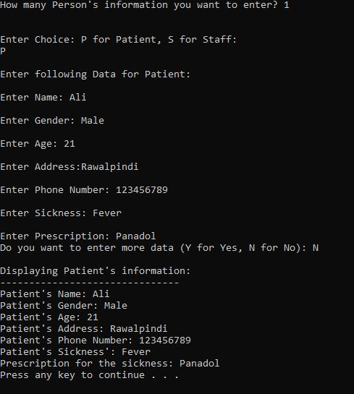
Figure 1: Sample Output

Best of luck!

NOTE: Do not put any query on MDB about this assignment, if you have any query then email at cs304@vu.edu.pk. Furthermore, if any student found cheating from any other student or from online forums then he/she will be awarded ZERO right away and strict disciplinary action will be taken against the student.

Deadline: Your assignment must be uploaded/submitted on or before January 27, 2021.

